"Театрдың ғажайып әлемі" атты аудандық байқауда мектебіміздің "Бәйшешек" театрлық ұжымы 1-орынды иеленді. Актерлік шеберліктерін көрсете білген 6,8,10-сынып оқушыларына алғыс білдіреміз.

[[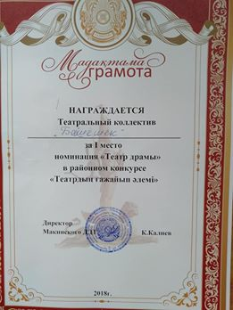](https://www.facebook.com/photo.php?fbid=1108245742685875&set=pcb.252005262175009&type=3&__tn__=HH-R&eid=ARAyfg90GNEfHcgvr7e-C5zZRj20whZhItiTQ_5BfedoHZUo-_yqaUBbC0DgiRFjD6vROVam-bn6D8q3)](https://www.facebook.com/photo.php?fbid=1108245742685875&set=pcb.252005262175009&type=3&__tn__=HH-R&eid=ARAyfg90GNEfHcgvr7e-C5zZRj20whZhItiTQ_5BfedoHZUo-_yqaUBbC0DgiRFjD6vROVam-bn6D8q3)

[[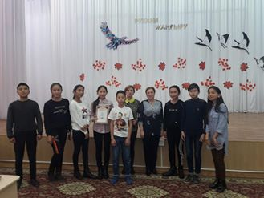](https://www.facebook.com/photo.php?fbid=1108245772685872&set=pcb.252005262175009&type=3&__tn__=HH-R&eid=ARDFypXIbs1qZOw3IMylV9mNM50Xlz-HD-gulO8o-Dtj3xDIMKOpmKSJlatGFpg-ue6FjbIX-nYuMiZu)](https://www.facebook.com/photo.php?fbid=1108245772685872&set=pcb.252005262175009&type=3&__tn__=HH-R&eid=ARDFypXIbs1qZOw3IMylV9mNM50Xlz-HD-gulO8o-Dtj3xDIMKOpmKSJlatGFpg-ue6FjbIX-nYuMiZu)

[[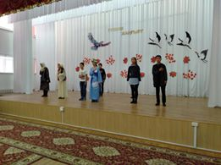](https://www.facebook.com/photo.php?fbid=1108245816019201&set=pcb.252005262175009&type=3&__tn__=HH-R&eid=ARBAwEMPW_PCF7qUbWL-e1D1DLFbERlrG1-7ocD-0D-6xxoDBWj4y6_TxxzpKf6Z0czKarcY0LI9r9NR)](https://www.facebook.com/photo.php?fbid=1108245816019201&set=pcb.252005262175009&type=3&__tn__=HH-R&eid=ARBAwEMPW_PCF7qUbWL-e1D1DLFbERlrG1-7ocD-0D-6xxoDBWj4y6_TxxzpKf6Z0czKarcY0LI9r9NR)

[[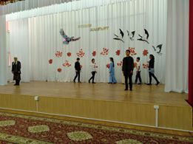](https://www.facebook.com/photo.php?fbid=1108245966019186&set=pcb.252005262175009&type=3&__tn__=HH-R&eid=ARBhKP-mJMyyM2a7MECQegzwf2hIN_YIpsr052Uo9TrukR5NU8a0oDq3Cd5fG7ZDBAgXK_Ui2AFQZ8ip)](https://www.facebook.com/photo.php?fbid=1108245966019186&set=pcb.252005262175009&type=3&__tn__=HH-R&eid=ARBhKP-mJMyyM2a7MECQegzwf2hIN_YIpsr052Uo9TrukR5NU8a0oDq3Cd5fG7ZDBAgXK_Ui2AFQZ8ip)

[+3](https://www.facebook.com/photo.php?fbid=1108246036019179&set=pcb.252005262175009&type=3&__tn__=HH-R&eid=ARCfCzOaleyWwLyrxWoCeQHERIn_cLdUC9jQmDMfh3L2h8OZRDMlK5CR-u7PW1RCpLBZjMceHidNZUoy)